

FACULTY OF ENGINEERING AND THE BUILT ENVIRONMENT

DEPARTMENT OF ELECTRICAL ENGINEERING TECHNOLOGY

Ramolatela Lebaea

221064591

NETWORKS 2B

Lab(3-1) FTP Configuration

12 October 2023

Dr. A. Alonge

Table of Contents

1. INTRODUCTION 2
   1. Objectives 2
2. APPARATUS 2
3. NETWORK DIAGRAM 2
4. CMD’S 3
5. QUIZ 9
6. CONCLUSION 9

Table of Figures

Figure 1: Network Configuration 2

Figure 2: Router 1 cmd 3

Figure 3: Router 1 cmd 4

Figure 4: Router 1 cmd 5

Figure 5: Router 1 cmd 6

Figure 6: Router 2 cmd 7

Figure 7: Router 2 cmd 8

# INTRODUCTION

## Objectives

The objective of this lab is to provide hands-on experience in configuring and utilizing FTP (File Transfer Protocol) for file management between network devices, with a focus on understanding FTP connection establishment, configuring FTP server parameters, and performing file transfers.

# APPARATUS

* 2× Routers
* GE connecting wires

# NETWORK DIAGRAM

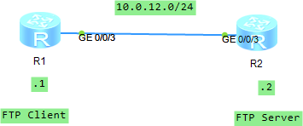

*Figure 1: Network Configuration*

# CMD’S

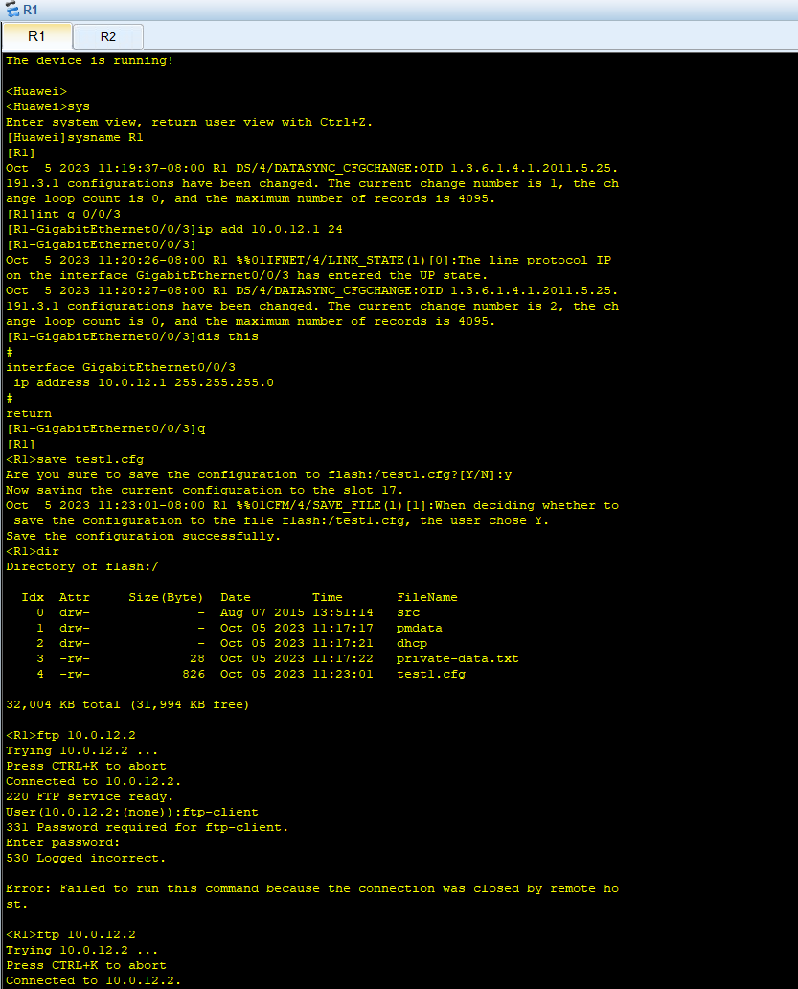

*Figure 2: Router 1 cmd*

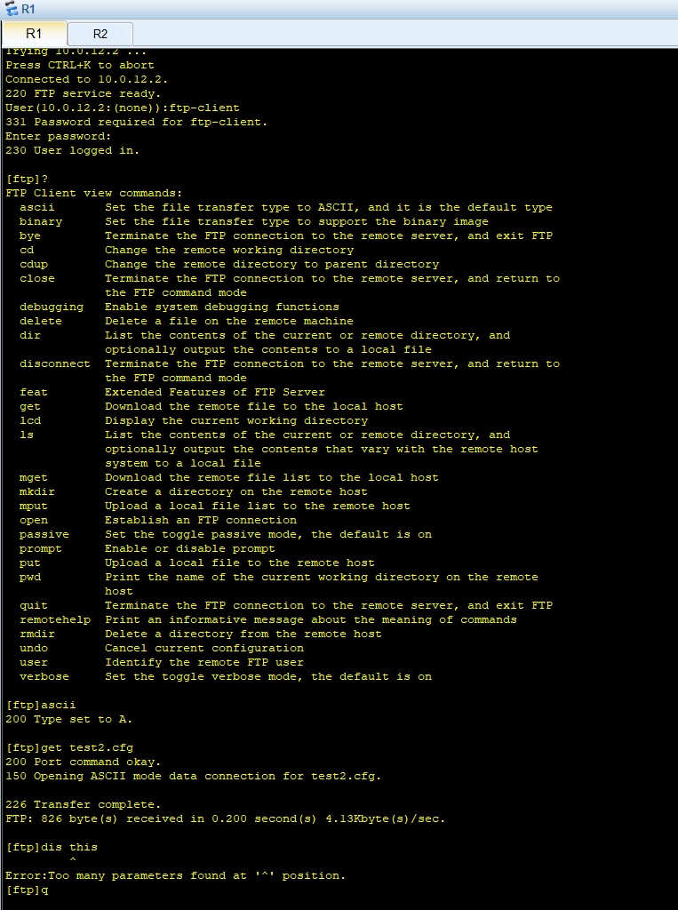

*Figure 3: Router 1 cmd*

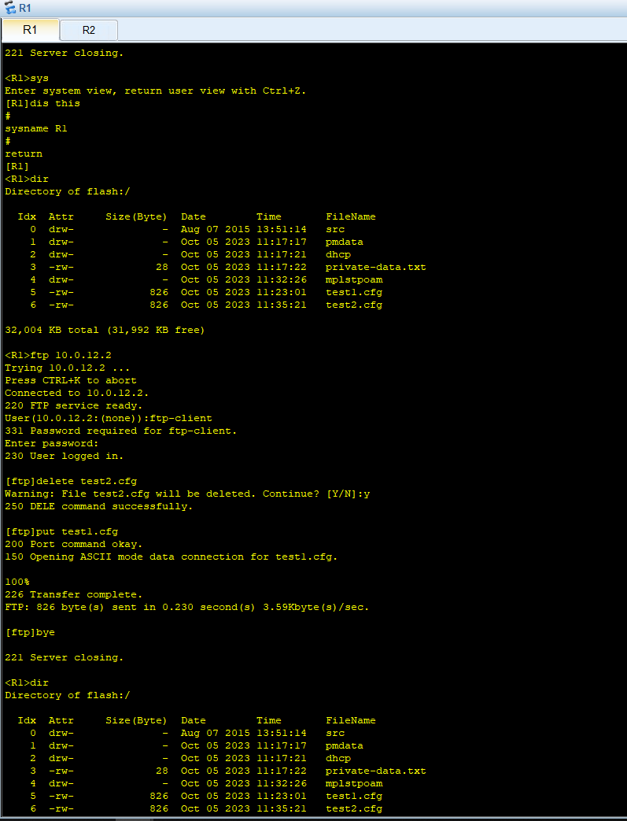

*Figure 4: Router 1 cmd*

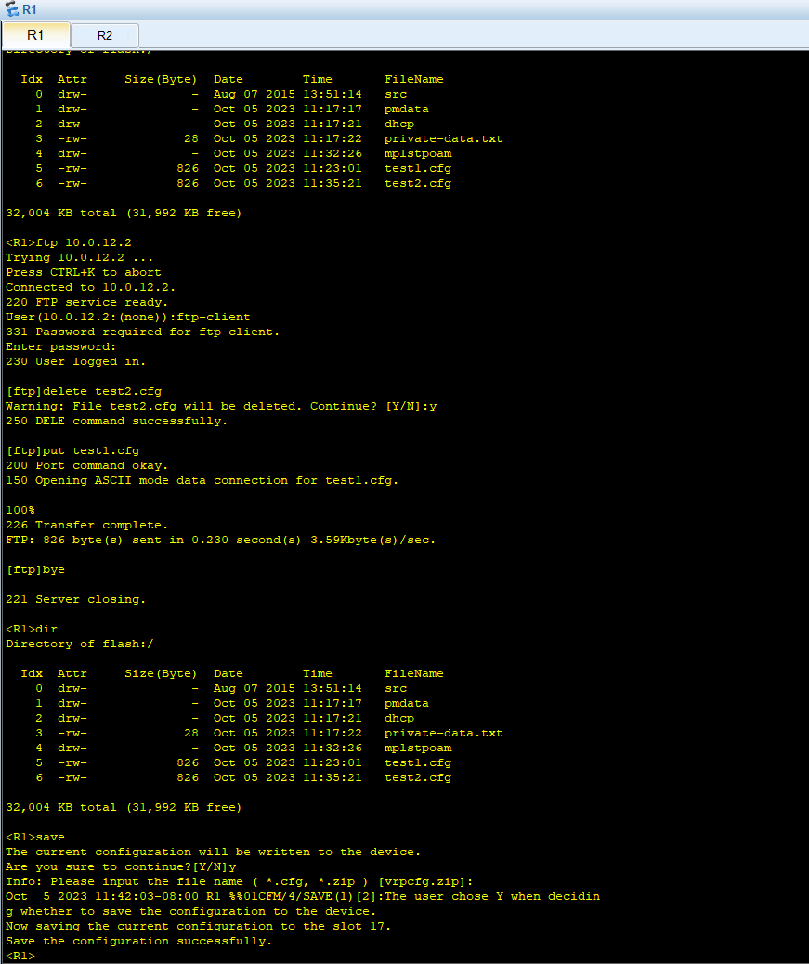

*Figure 5: Router 1 cmd*

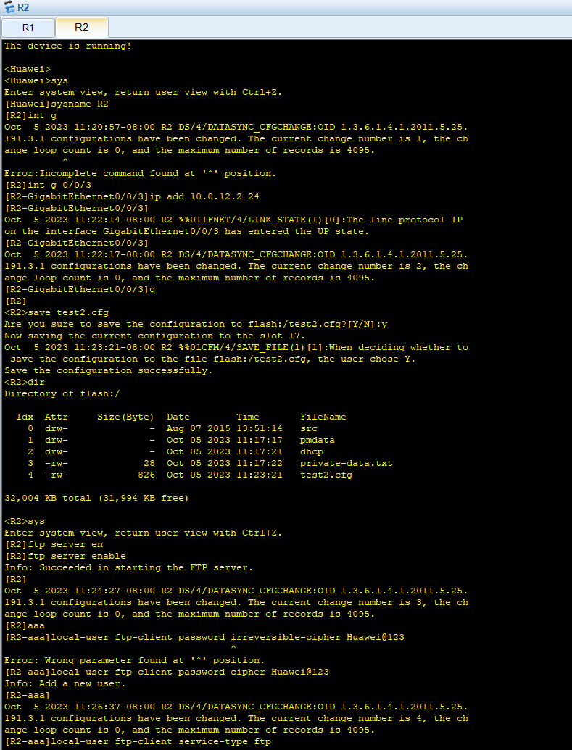

*Figure 6: Router 2 cmd*

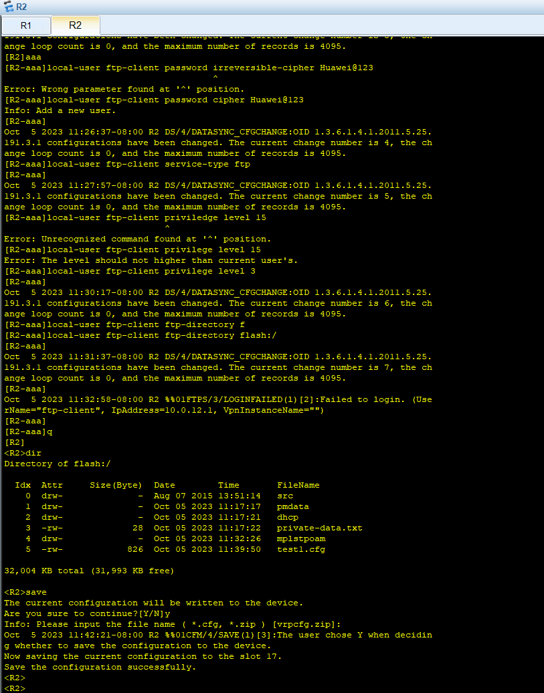

*Figure 7: Router 2 cmd*

# CONCLUSION

In conclusion, Lab 1 focused on configuring FTP (File Transfer Protocol) services between two devices, R1 and R2, to understand how an FTP connection is established, configuring FTP server parameters, and performing file operations between the two devices. The lab involved configuring basic device settings, enabling the FTP server function on R2, creating local FTP users, logging into the FTP server from the FTP client (R1), and performing various file operations such as downloading, deleting, and uploading files. The verification step confirmed the successful execution of these operations, and the lab reference provided configuration examples for R1 and R2.

This lab was really helpful because it taught me how FTP works and how to use it to transfer files between devices.